HOW TO CREATE A RESOURCE GROUP AND VIRTUAL NETWORK IN MICROSOFT ENTRA ID

As part of my continuous learning in cloud infrastructure I am sharing a step-by-step process on how to:
- Create a Resource Group
- Create a Virtual Network (VNET)

These are the essential building blocks in any cloud environment.

CREATE A RESOURCE GROUP ON AZURE PORTAL
Step 1: Sign in to Azure Portal

Visit “https://portal.azure.com” and sign in with your Microsoft Account.

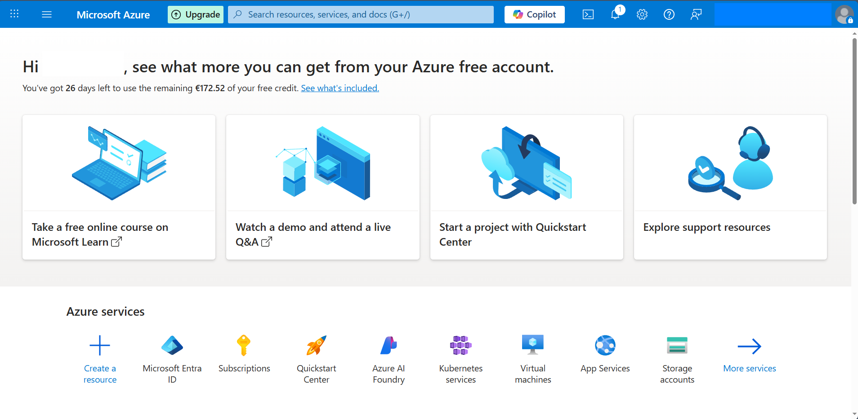

Step2

•On the Click on the Search bar and enter “Resource Group”

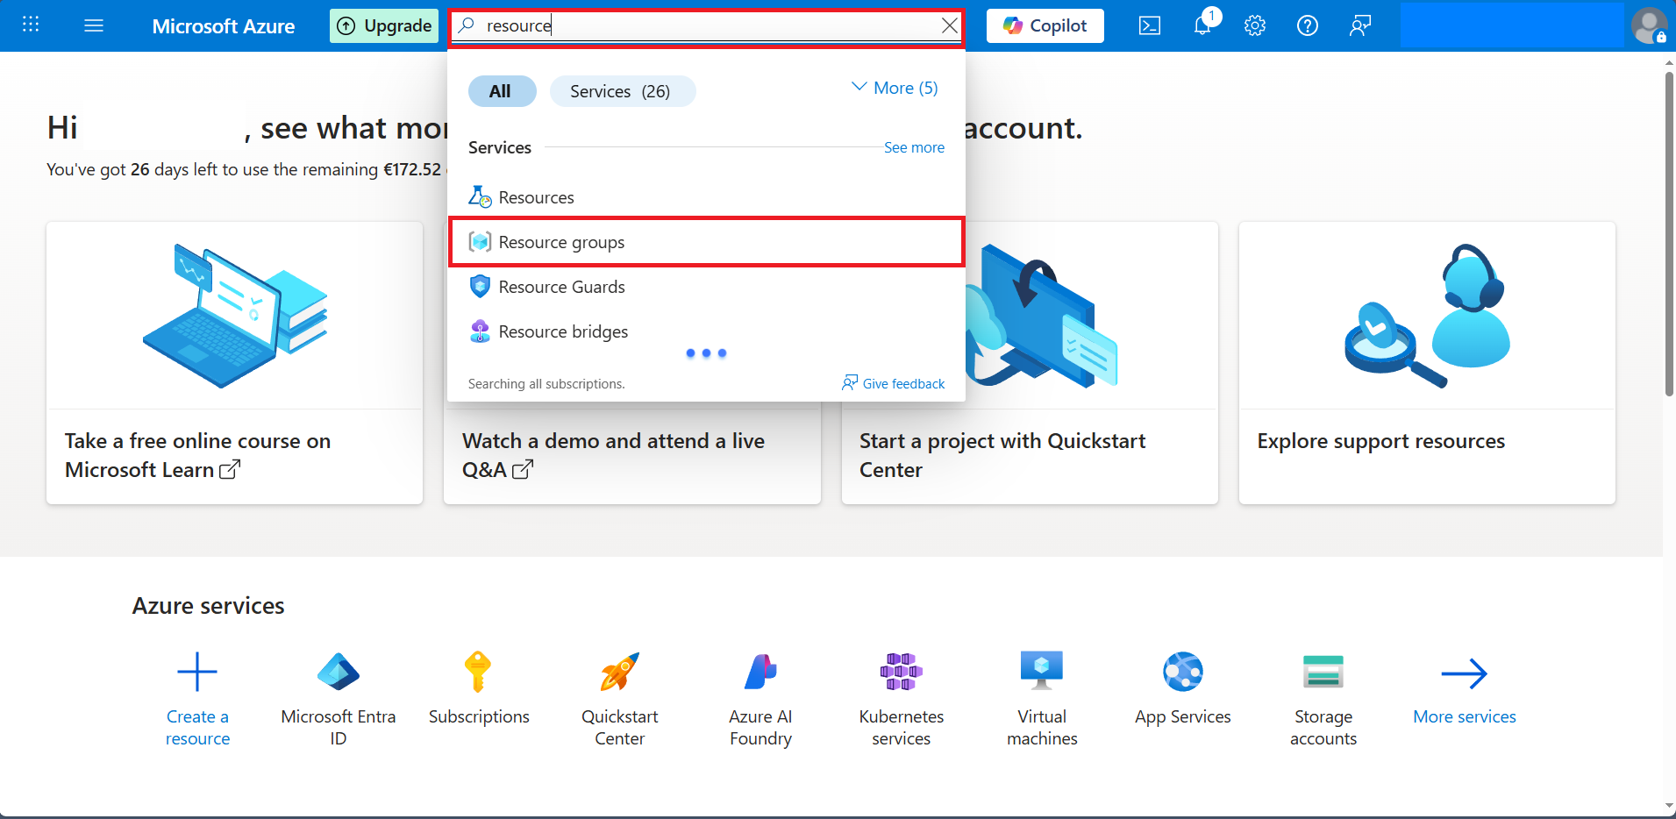

• Resource Groups Page, click on “Create” and begin the process.

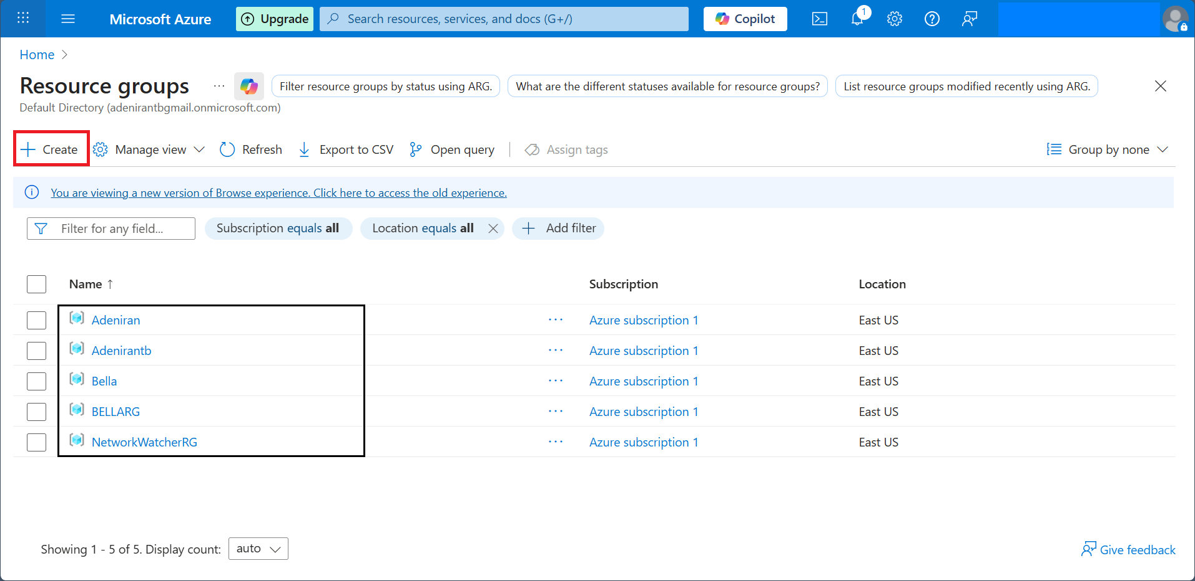

•Choose a Subscription

Select the Appropriate Azure Subscription under which the resource group will be created.

•Specify a resource Group Name for Example BELLA RG

•Select a Region choose a region closest to your users or that complies with your data

residency requirements.ie US EAST, US WEST, WEST EUROPE, etc.

•Click Review Create
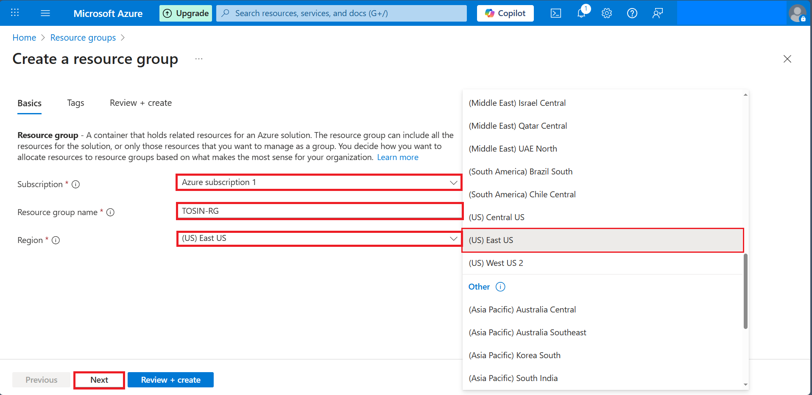

Apply Tags as the name shows the owner of the Resource Group and Click Next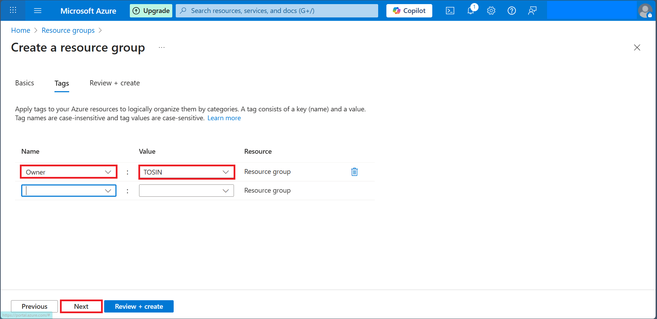

After filling all the information Click on Create.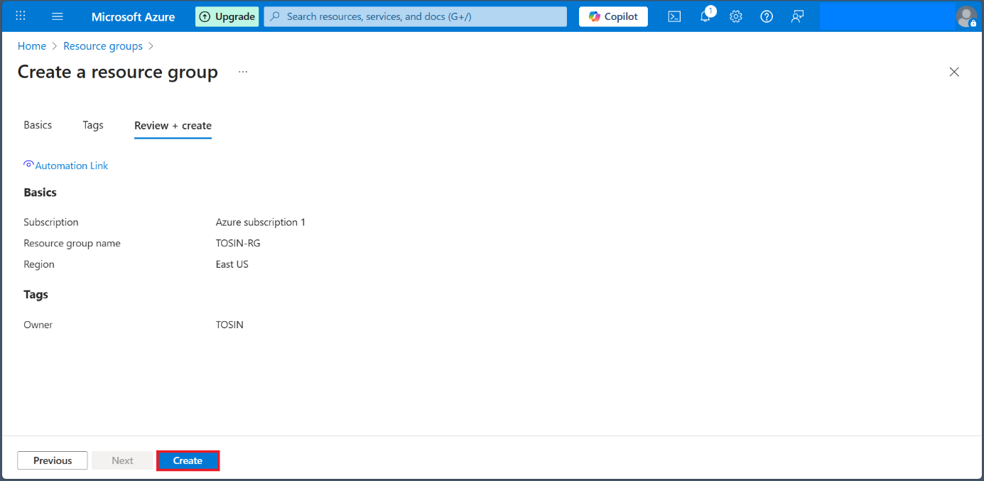

Resource Group showing the Azure Subscription and Location 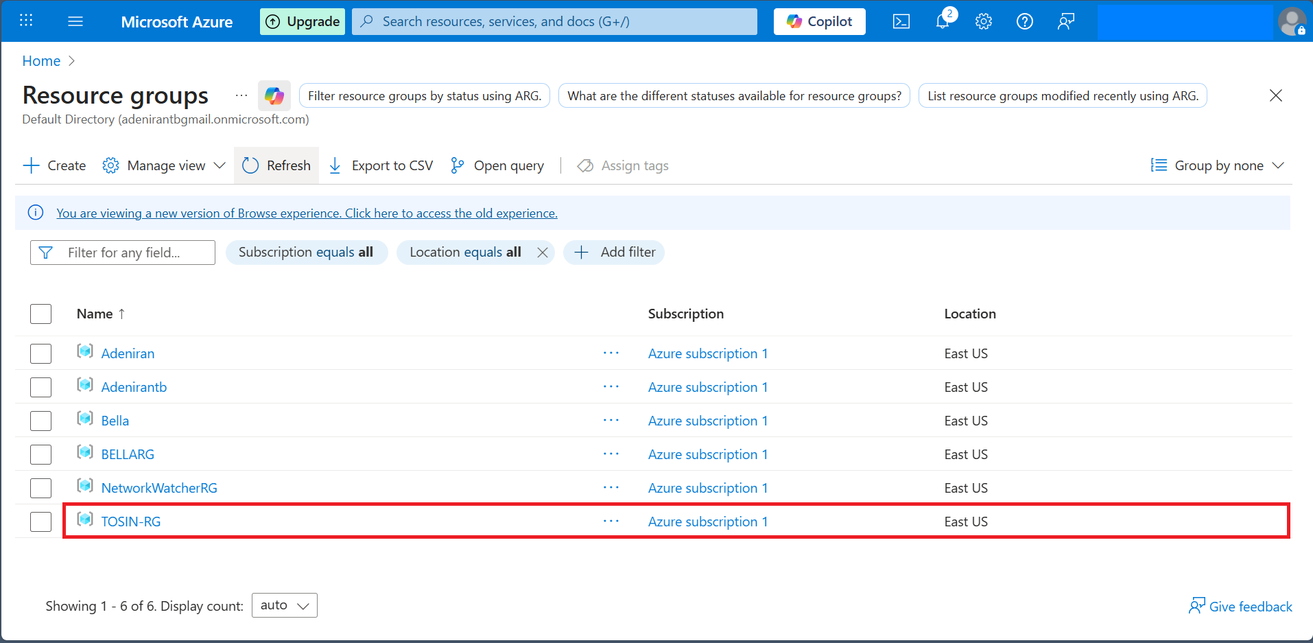

Resource Group Created

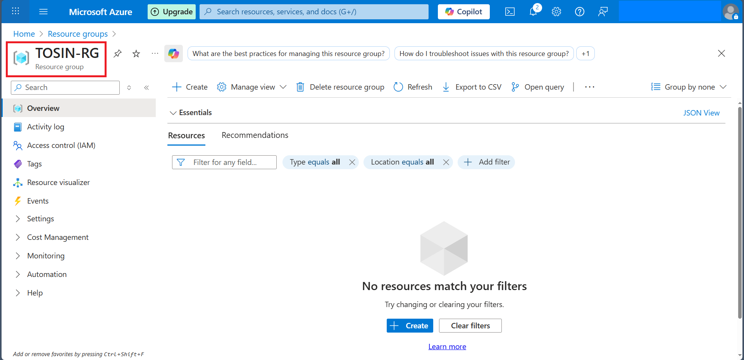

CREATE A VIRTUAL NETWORK ON AZURE PORTAL

Step 1: Sign in to Azure Portal
- Visit “https://portal.azure.com” and sign in with your Microsoft Account.
On the Click on the Search bar and enter “Virtual network

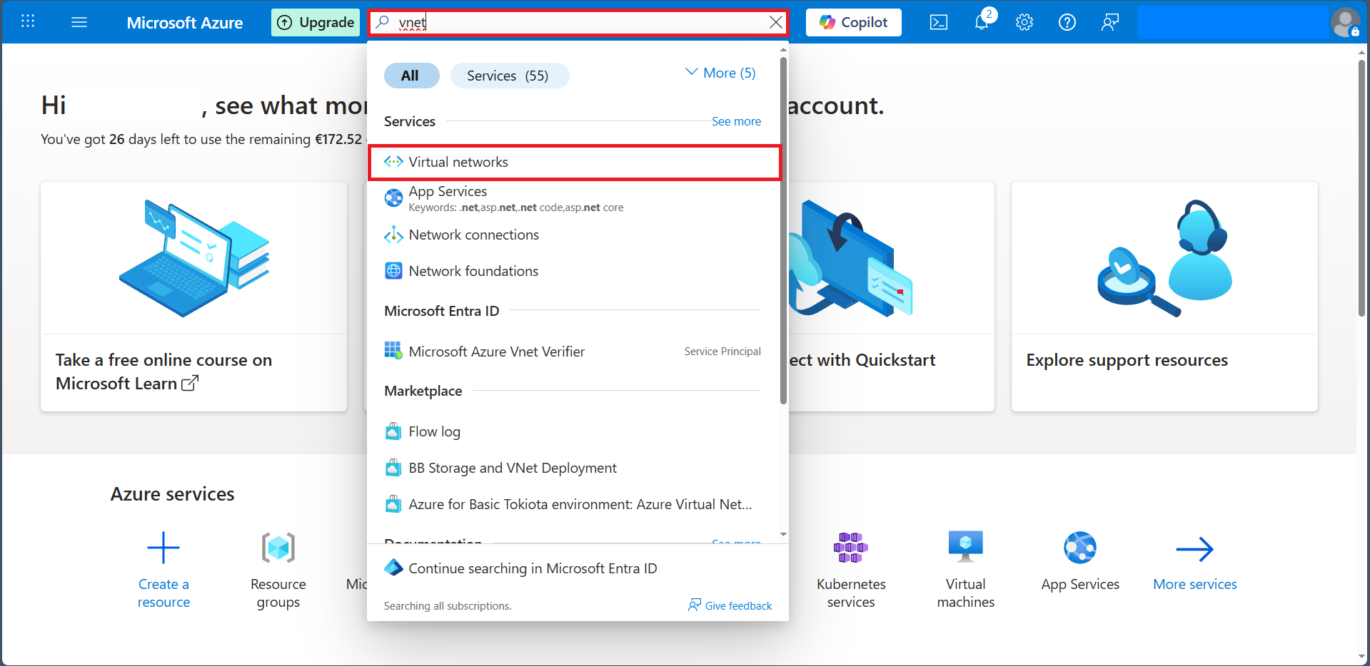

Click on Create

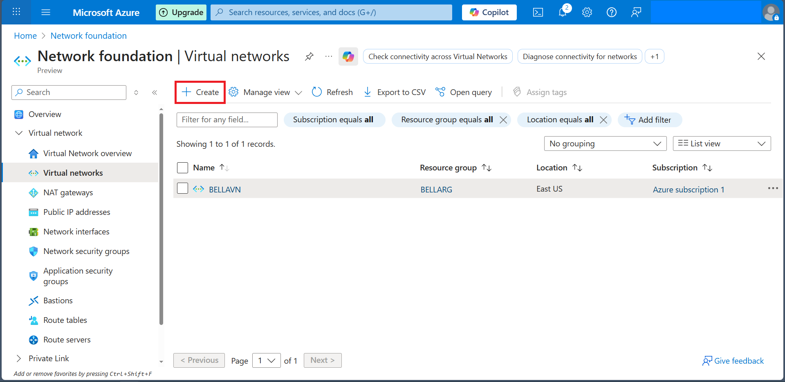

•Subscription> select your active subscription
Resource Group i.e. the one you created BELLA RG or TOSINRG
•Name< Enter a name for the VNET for example* BELLA RG*
•Match the region of your group
•Click on NEXT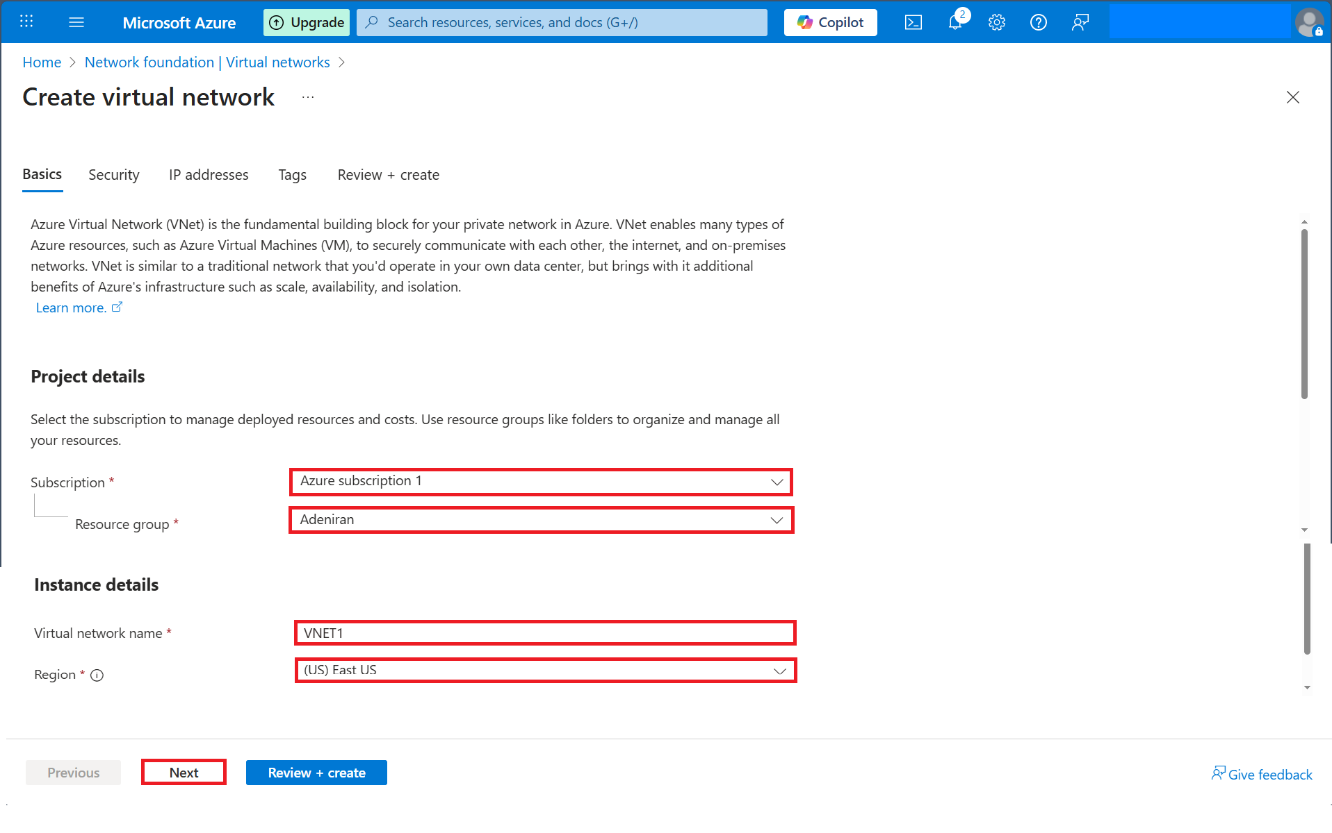

Click on Next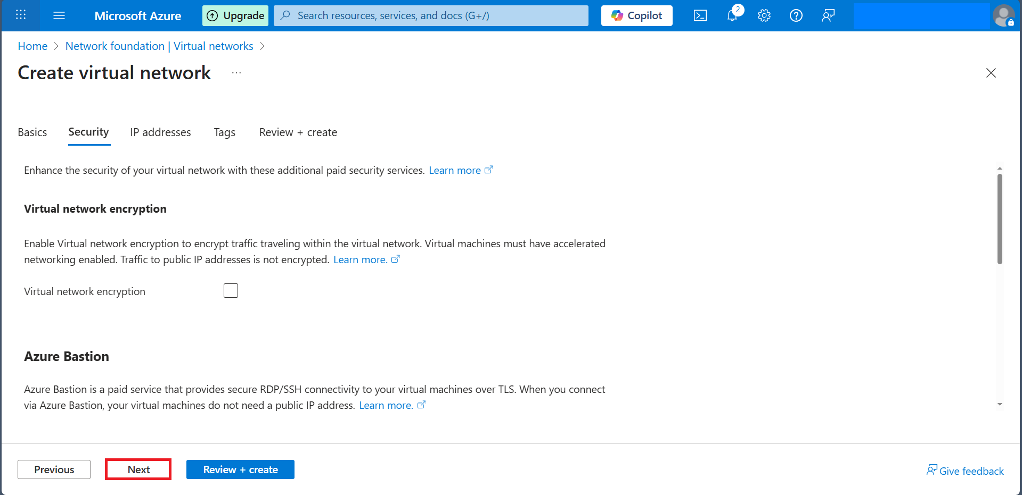

Step 3 IP Addresses
•By default, Azure provides a 10.0.0.0/16
•you can modify the subnet for now keep the default e.g. Subnet name default >Subnet range 10.0.0.0/24
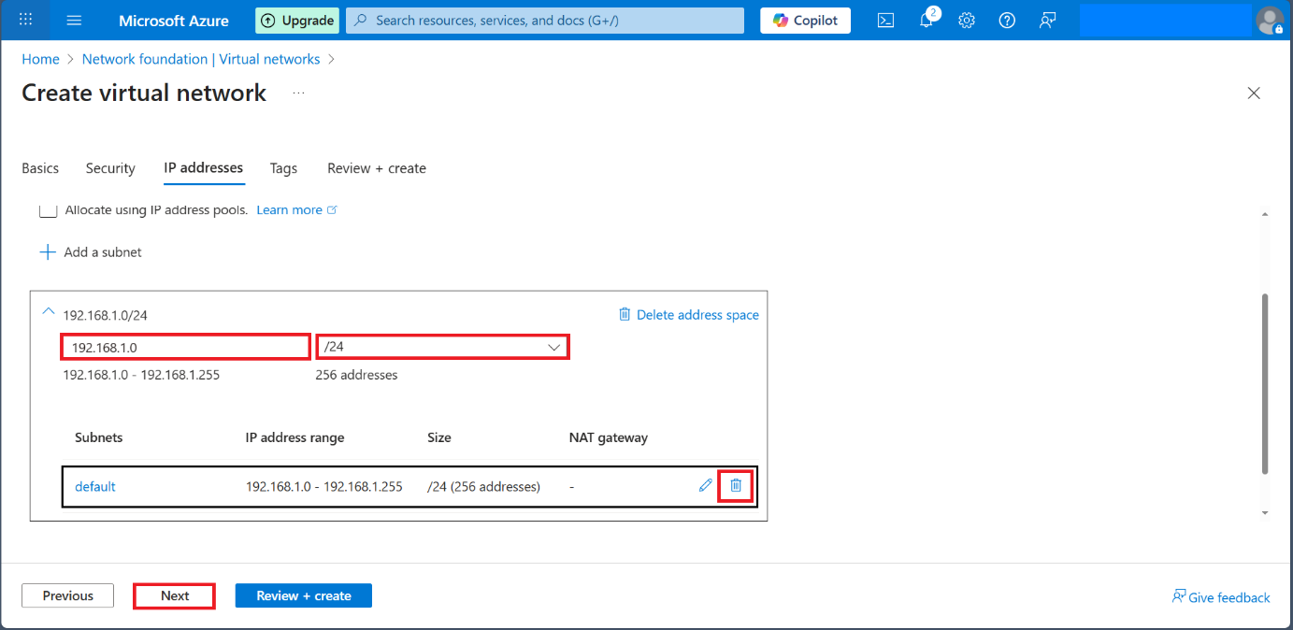

Review and Create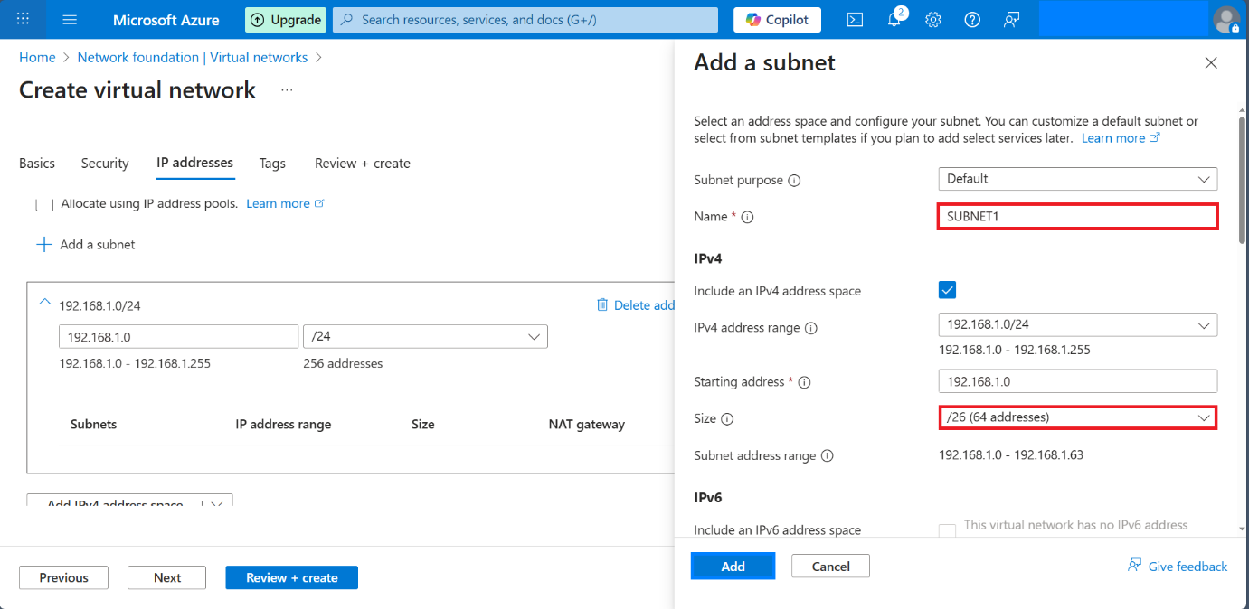

In other to Create a small network the IP Addresses and Subnet has to be changed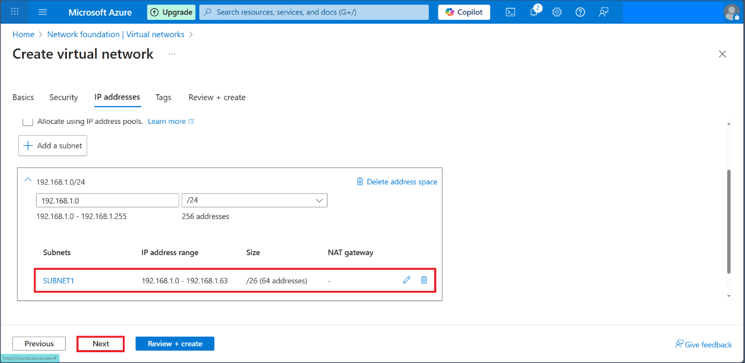

Filling all the information in other the owner of the Virtual Network and Click Next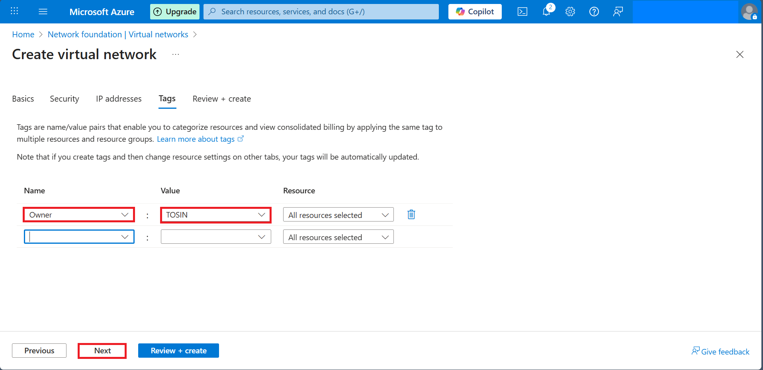

Creating a virtual network inside that resource group this VNET will allow other Azure resources like VMs to securely communicate.
•in the top search bar type virtual networks and click on it
•Click on Create

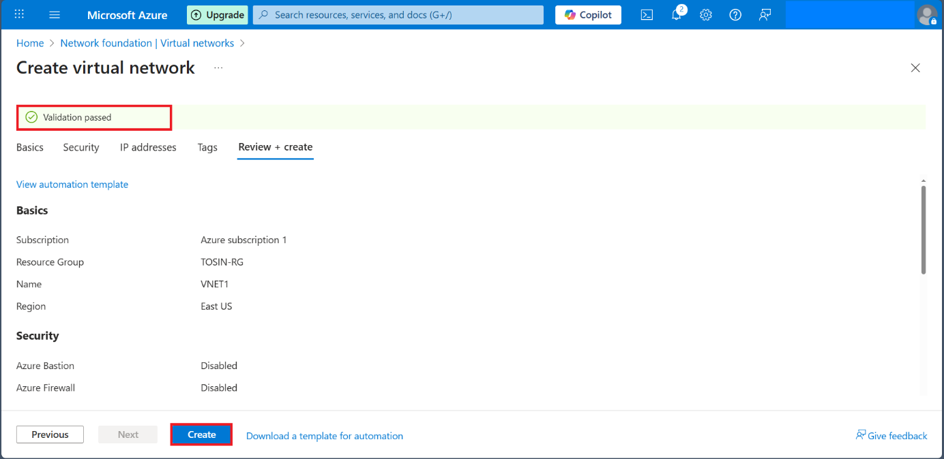

Virtual Network VNET is complete