Step by step how to create a virtual Machine in Azure connecting securely using RDP.
Step1 Sign in to Azure Portal
• Go to portal.azure.com and log in.
• you will get on the Azure welcome dashboard.
• use the search bar at the top to find Virtual machines.
• select a virtual machine and press the Create button.
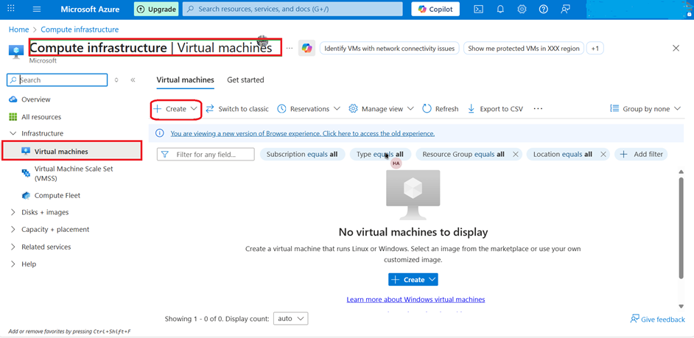

Step2.
• Select your Azure Subscription-Azure Subscription 1
• Add your Resource group-BellaRG
• Navigate to the next page.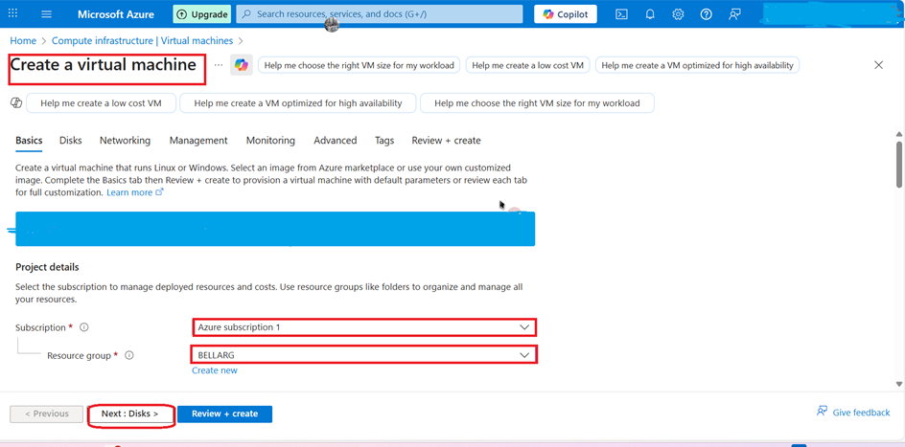

Step3.
• Name your virtual machine-BellaVM
• Add a region - US East
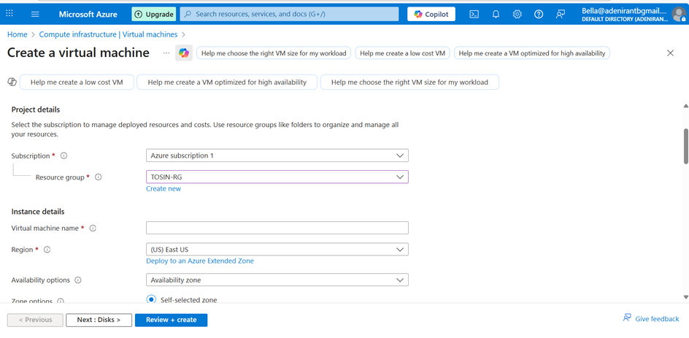

Step4.
•Choose a user name, Password, select public inbound ports.
•Navigate to the next page.

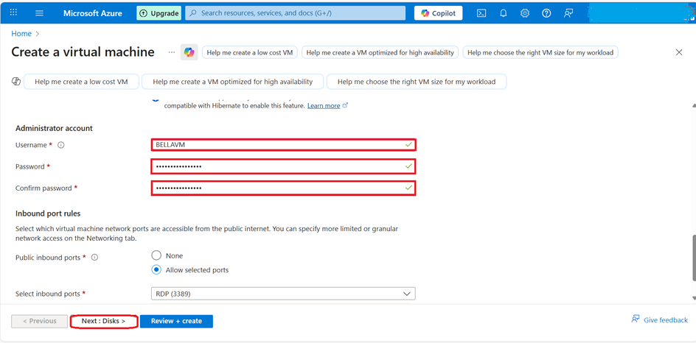

Step5.
•Select your disk Size -127 GIB
•Select OS disk type premium SSD locally-redundant Storage

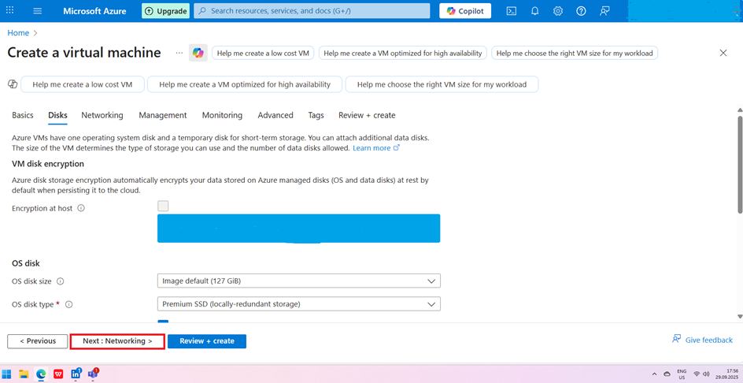

Step6.
• Creating a virtual machine in a cloud environment, selecting a subnet determines how the VM will connect to the network.
• Using a default Subnet when creating a VM are automatically configured to assign public IPs
• Choosing your IP-when you launch a VM,it needs an IP address so it can communicate with other systems.
• Navigate to the next page.

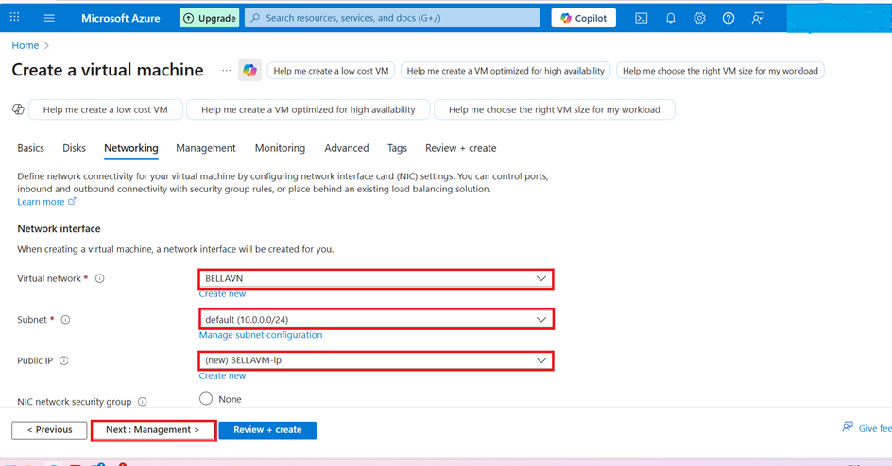

Step7.
• To Enable Monitoring options for VM
• you need to select storage account
• Either pick an existing storage account or create a new one.
• Navigate to the next page.
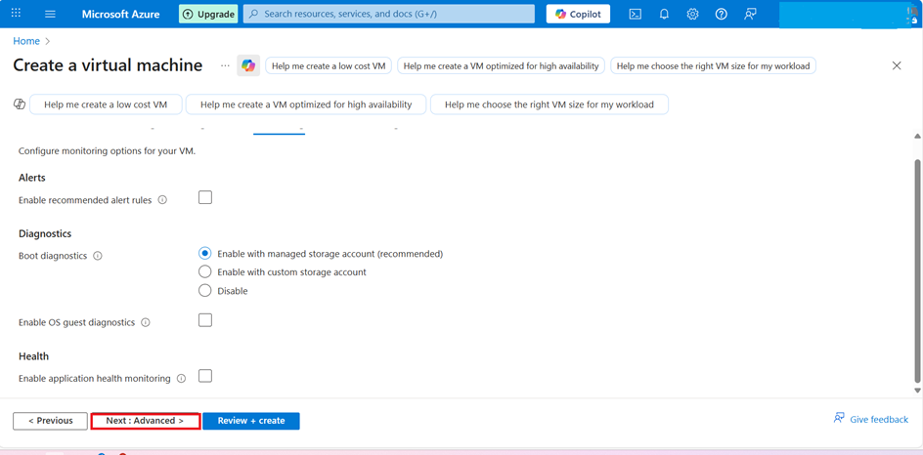

Step8.
• Click on Next
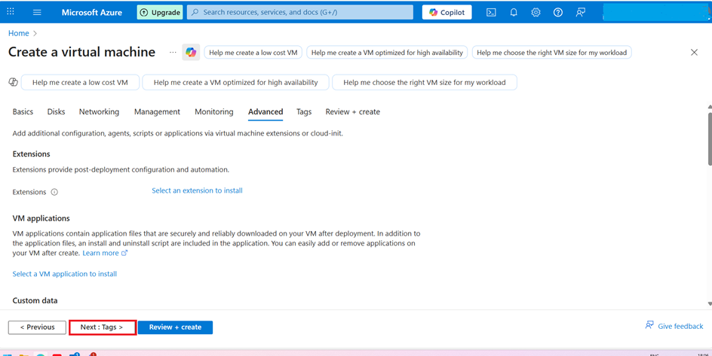

Step9.
• Click on Next
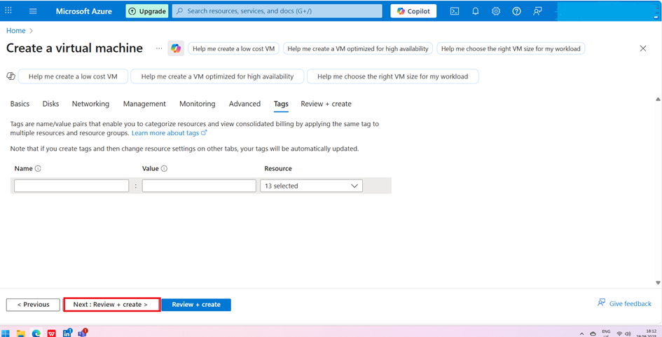

Step10.
•Move on the final page to click on Create
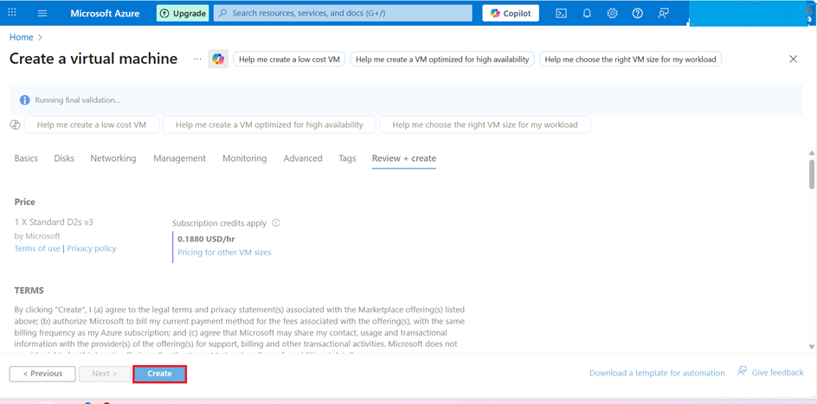

Step11.
• Your Virtual machine is now created. 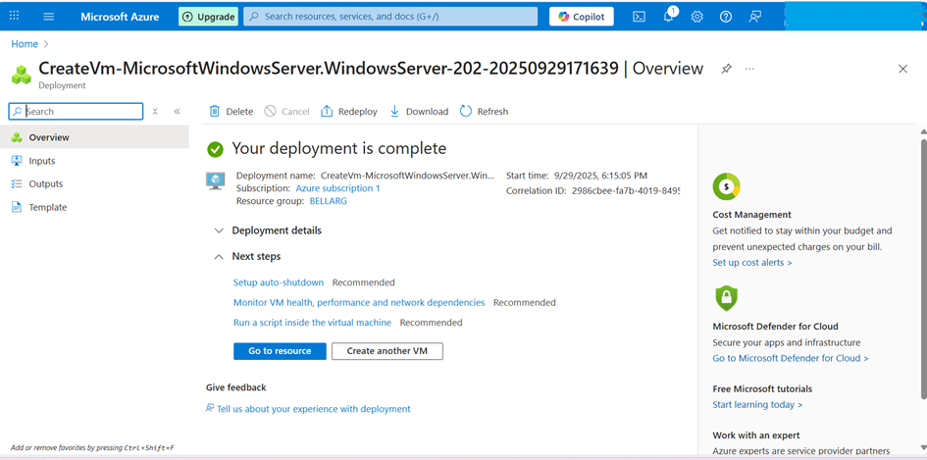

Step12.
• Overview of BELLA Virtual Machine.
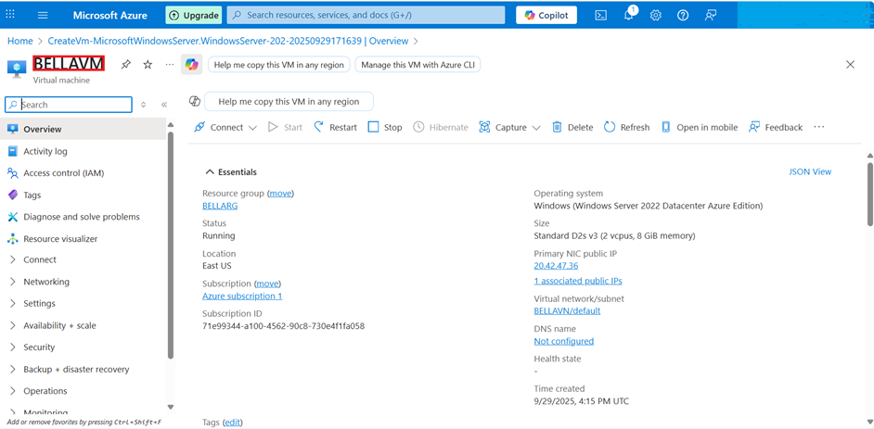

Step13.
•Now is the time to Navigate to download the RDP file.
•Port 8389 (remote desktop protocol) for testing purposes only, for production is not allowed.

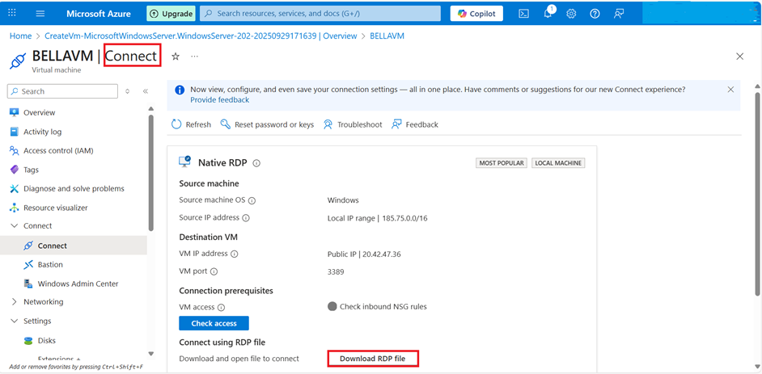

Step14.
•Downloading the RDP file.
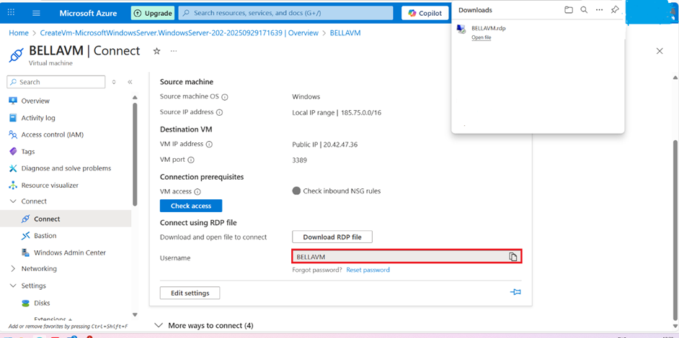

Step15.
•Connecting the RDP file to the Virtual Machine. 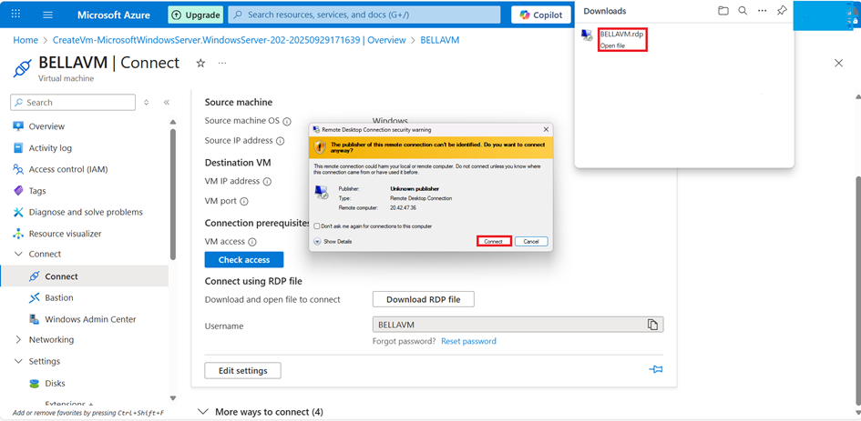

Step16.
•Signing in with your user name and password in order to connect the virtual machine.
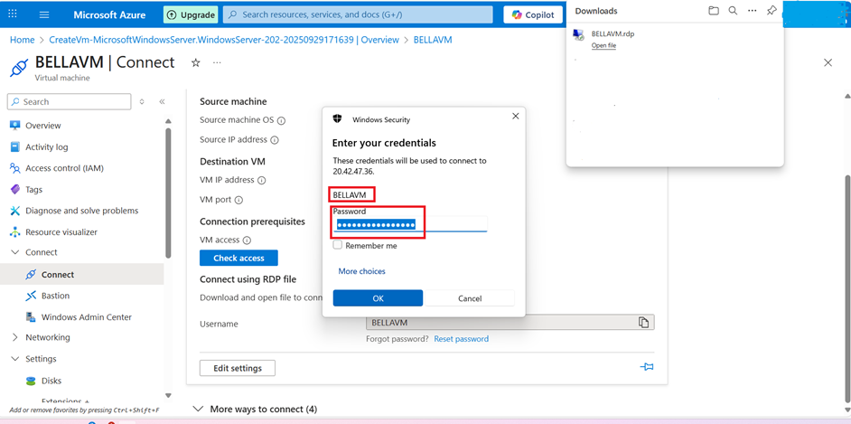

Step17.
•you have now connected the virtual machine securely with RDP. 